Name Surname *
University
Country
Name Surname Author 2
University
Country
(Franklin Gothic Book font, 10-point type size, author name(s) bold)
- TITLE TITLE TITLE TITLE TITLE TITLE TITLE TITLE TITLE (CONCISE AND INFORMATIVE. WITHOUT ABBREVIATIONS. FRANKLIN GOTHIC BOOK 16 PT. CAPITAL LETTERS UPPER CASE, SINGLE SPACES BETWEEN THE LINES, LEFT ALIGNED)
Abstract: Times New Roman 9 pt., bold, interline before - 6 pt and after the line 3 pt. Your abstract should be a maximum of 250 words here clearly outlining the contribution of your paper (the major objective, the research design, the methods and procedures employed, the main outcomes and results, the conclusions from data and results, implications for further research). For the abstract use Times New Roman font, 9-point type size, fully justified.
Keywords: Times New Roman 9 pt., interline before and after the line 6 pt. Maximum of 5 key words, alphabetical order, separated by commas.
JEL Classification: Times New Roman 9 pt., separated by commas, interline before and after the line 6 pt. Indicate appropriate JEL classification codes (http://www.aeaweb.org/journal/jel_class_system.html)

1. Introduction (Main point, Franklin Gothic Book 12 pt. bolded, single spaces between the lines, interline before and after the line 6 pt.)
Your paper should be in the same format as this file. Arrange the text in one column. Paper should be not shorter than 6 pages and should not exceed 8 pages total (including references). The article must be entirely original, not previously published, and must not be under concurrent consideration or scheduled for presentation elsewhere. The article should be written in the Microsoft Word format, paper size A4, margins 2,5 cm each. Normal text of the paper Times New Roman 11 pt. character, single spacing, justified text body, indent 0,5 cm.
First paragraph of the section without indentation at the beginning of the first line. Second and following paragraphs of the text have initial indentation of 0,5 cm.
- Enumeration with hyphens, single spaced.
Your document should be written in English language in the same format as this file. The structure of the paper should be as follows: names of authors, affiliation, e-mail address, title, abstract, keywords, introduction, body of paper – sections and subsections (methodology of research, results of research, discussion), conclusion, acknowledgements (if any) and references.
All authors must take care of the language revision by they own. The language must be clear and accurate. The work should be written in an impersonal style. If English is a second language for the author, please consider having the manuscript proof read and edited before submitting.
Introduction should provide wider context, substantiation of the need of writing and publishing the paper, and its goal.

2. Body of Paper – Sections (Headings - Franklin Gothic Book 12 pt. bolded, single spaces between the lines, interline before and after the line 6 pt.)
Your paper will be part of the conference proceedings. Therefore we ask that authors follow the guidelines explained in this example. Be advised that papers in a technically unsuitable form will be returned for retyping. After returned the manuscript must be appropriately modified.
Body of paper – sections and subsections (methodology of research, results of research, discussion). For the body of your document use Times New Roman font, 11-point type size, single-spaced. The whole document should be fully justified (not only left-justified).
Section, section, section, section, section, section, section, section, section, section, section, section, section, section, section, section, section, section, section, section, section, section, section, section, section, section, section, section, section, section, section, section, section, section.
2.1. Body of Paper - Subsections (Subheadings - Franklin Gothic Book 11 pt. bolded, 6 pt. interline before and after the line)
For the body of your document, use Times New Roman font, 11-point type size, single-spaced. The whole document should be fully justified (not only left-justified).
Subsection, subsection, subsection, subsection, subsection, subsection, subsection, subsection, subsection, subsection, subsection, subsection, subsection, subsection, subsection, subsection, subsection, subsection, subsection.
3. Conclusion (Franklin Gothic Book 12 pt. bolded, single spaces between the lines, interline before and after the line 6 pt.)
Conclusion should contain evaluation and exact description of achieved results provide a confrontation of the achieved results with previously published papers, author’s opinion of established differences, his/her attitude to the results. Also indicate advantages, limitations, and possible applications.
Acknowledgements (Franklin Gothic Book 12 pt. bolded, single spaces between the lines, interline before and after the line 6 pt.)
An acknowledgement is necessary when the realization of the paper was supported by a grant agency or other external resources. Always state the full name of the organization which provided funding for the project and its number in square brackets. E.g. This paper was supported by Grant Agency [No 1234567890]. A brief acknowledgement section may be included between the Conclusion and References (optional).
References (Franklin Gothic Book 12 pt. bolded, single spaces between the lines, interline before and after the line 6 pt.)
Use the provided citation style for references. APA style for writing references in the reference list must be used. Make the list of references in alphabetical order. The list of references must contain only items cited in the text. References should be written in Times New Roman 9 pt, Block-aligned, single spaces, interline after the line 6 pt.) and should be prepared in Roman script.
The used references should be relevant, actual and international. The preferred number of references is 25-30. We strongly recommend the use at least a few references indexed in the Web of Science database.

Examples of citation

Book
Gorzeń-Mitka, I. (2007). Risk in export. Warszawa: KeyText.
Chapter in a book
Okręglicka, M. (2012). Leasing Activity in the Era of the Economic Crisis in Poland. In A. Malina, R. Oczkowska, T. Rojek (Eds.), Knowledge - Economy - Society. Dilemmas of the Contemporary Management (pp. 213-224). Cracow: Foundation of the Cracow University of Economics.
Journal Article
Gorzeń-Mitka, I., Okręglicka, M. (2014). Improving Decision Making in Complexity Environment. Procedia Economics and Finance, 16(1), 402-409.
Conference papers and proceedings
Sipa, M., Skibiński, A. (2015). Innovative Strategies of Small Enterprises in Poland. Proceedings of 12th International Conference Liberec Economic Forum 2015, 342-352. Liberec: Technical University of Liberec.
Electronic publications
Author, A. (2015). Title of electronic publications, [online]. Available: http://www.full_link_to_access.pdf. [2015, January 01].
In the reference list, provide the citation for the work in its original language. Also provide an English translation of the title of the work in square brackets after the foreign-language title, without italics.
Doutre, É. (2014). Mixité de genre et de métiers: Conséquences identitaires et relations de travail [Mixture of gender and trades: Consequences for identity and working relationships]. Canadian Journal of Behavioural Science/Revue canadienne des sciences du comportement, 46, 327-336.
Paper Format Guidelines
Tables, Figures and Mathematic formulas
All the Tables, Figures and Mathematic formulas should be numbered.
Tables
Tables should be adjusted and numbered. If it is possible the whole table should be placed on one page. Text in table:
Table rows:
first - Times New Roman 10 pt. , bolded, centered.
next - Times New Roman 10 pt. , left aligned.
Table 1. Table title (Times New Roman 10 pt. bolded, 6 pt. spaces before and after the lines, adjusted)
First row | First row | First row | First row | First row | First row
Next row | Next row | Next row | Next row | Next row | Next row
Next row | Next row | Next row | Next row | Next row | Next row
Next row | Next row | Next row | Next row | Next row | Next row
Next row | Next row | Next row | Next row | Next row | Next row
Next row | Next row | Next row | Next row | Next row | Next row
Source: (Times New Roman 9 pt., 6 pt. spaces before and after the lines, adjusted)
Figures
Figures should be also adjusted and numbered. The whole figure on one page. Images must be computer-designed and submitted as EMBEDDED images in your document. All figures will be processed as images. Figure resolution should be at least 300 dpi. Figures should be legible, the optimal font size 9 Times New Roman, black-and-white or grayscale.

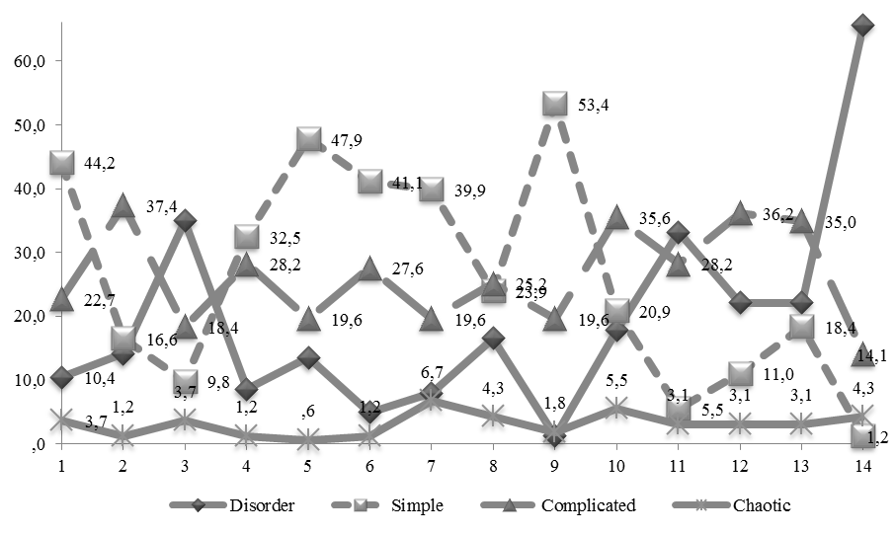
Figure 1. Figure title (Times New Roman 10 pt. bolded, 6 pt. spaces before and after the lines, adjusted)
Source: (Times New Roman 9 pt.adjusted)

Mathematic formulas
Mathematic formulas should be centered and numbered. Numbering is right aligned. To write Formulas, you should use Microsoft Equation. Text in mathematic formulas: Times New Roman 10 pt., centered, variables in italics.
(1)

Additional information:
Reference Text and Citations: References in the text should be presented in brackets (Gorzeń-Mitka, Okręglicka, 2014; Lemańska, 2016). If necessary, the page can be indicated: (Okręglicka, 2012, p. 214). The list of references should be presented after the text. The author should make sure that there is a strict one-to-one correspondence between the names and years in the text and those on the list. The all references should be listed in alphabetical order by author's name. Manuscripts in which references are not prepared in required way will be returned without review.
Acronyms: Acronyms should be defined the first time they appear.
Paper size: A4 (210 mm by 297 mm)
Justification: Full justification of the document.
Page numbers: no page numbers
Footnotes: generally no footnotes, if it’s necessary the footnotes at the lower part of page Times New Roman 9 pt., single spaced (example).
Color of text and figures: the paper is only printed in black-white color. Figures should be legible, the optimal font size 9 Times New Roman, black-and-white or grayscale.
Document should be not shorter than 6 (full) pages and should not exceed 8 pages.

Academic degree Name Surname; full contact address, e-mail addresses e.g. Ing. Anna Lemańska-Majdzik Ph.D.; Dąbrowskiego 69, 42-201 Częstochowa, Poland, lemanska@zim.pcz.pl
Academic degree Name Surname; full contact address, e-mail addresses * Corresponding author
Footnotes, footnotes, footnotes, footnotes.

